GRAHAM AND DODDSVILLE


HOME PAGE & SECONDARY PAGES
Please make sure that all articles are sourced from the attached Excel spreadsheet as well as from Google News or Yahoo Finance Australia News.
There should be more space between the image and the first article heading. Do this for all the other images.
The image should be thin as per the image below. Do this for all the other images in the Home Page.

The “LATEST NEWS” articles are being duplicated both within a subheading (eg. “Companies”) and between two subheadings (eg. they appear in both “Companies” and “Economy”)

This article heading does not lead to an actual article; only to the Berkshire Hathaway annual reports
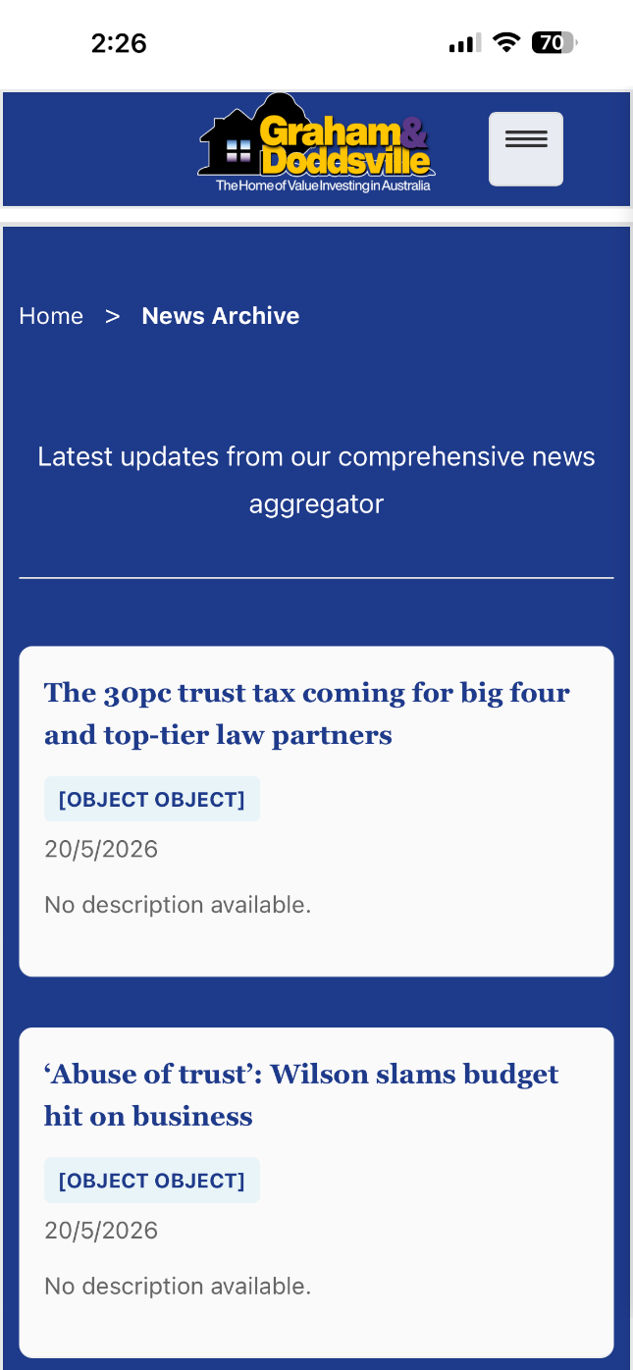
At the moment, all of the news secondary pages only display 5 articles. There should be at least 20 (and the first 5 of those should be the articles displayed in the Home Page).
The “[OBJECT OBJECT]” and “No description available” needs to be deleted. We cannot add any news content here as it would be breach of copyright.
The article heading should be clickable and take the user to the external website.
Is it possible to remove a lot of the space before and after this text?

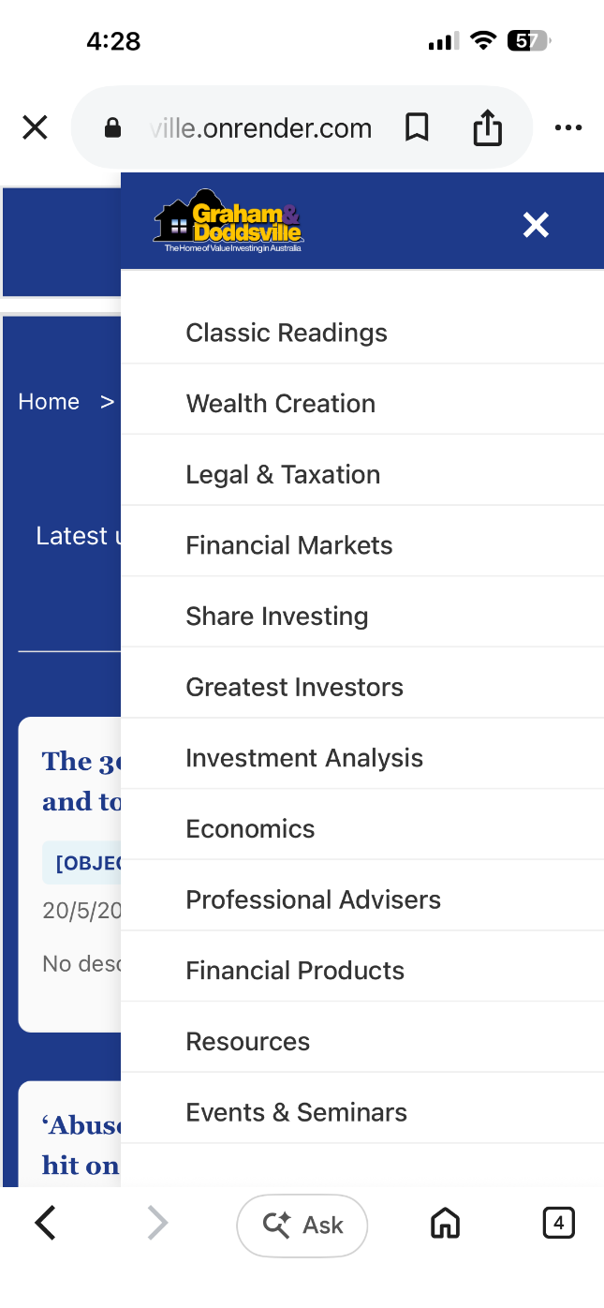
This “Home” button doesn’t work.
The dropdown menu, when accessed from the secondary pages, shows the old version (ie. without “Home”, “Financial Statement Analysis” and “Stock Valuation”).
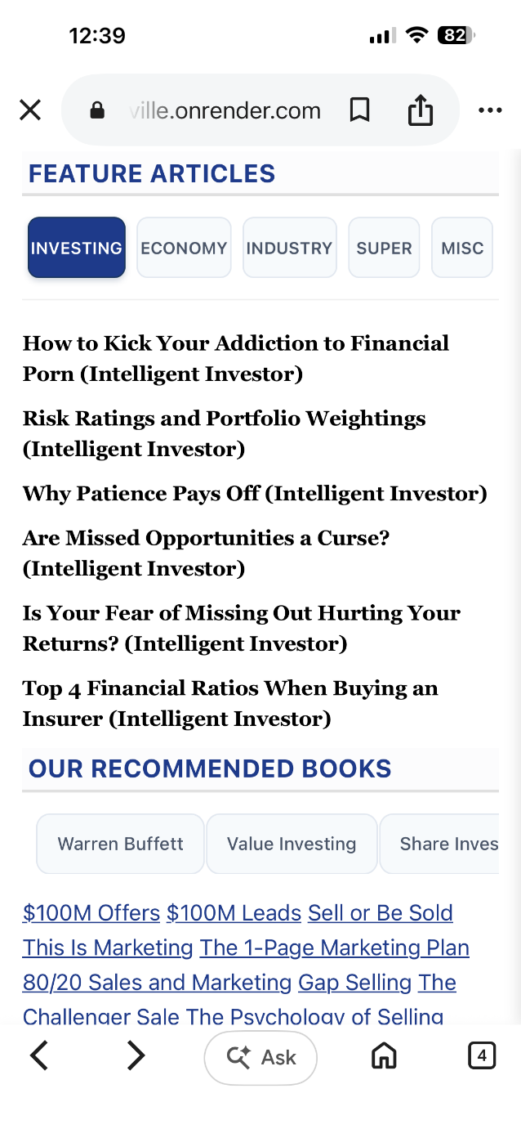
Can we make the source of each article (eg. “(Intelligent Investor)” light gray? And perhaps a different font that is slightly smaller, like Arial.
There needs to be an extra line space between “OUR RECOMMENDED BOOKS” and the preceding line.

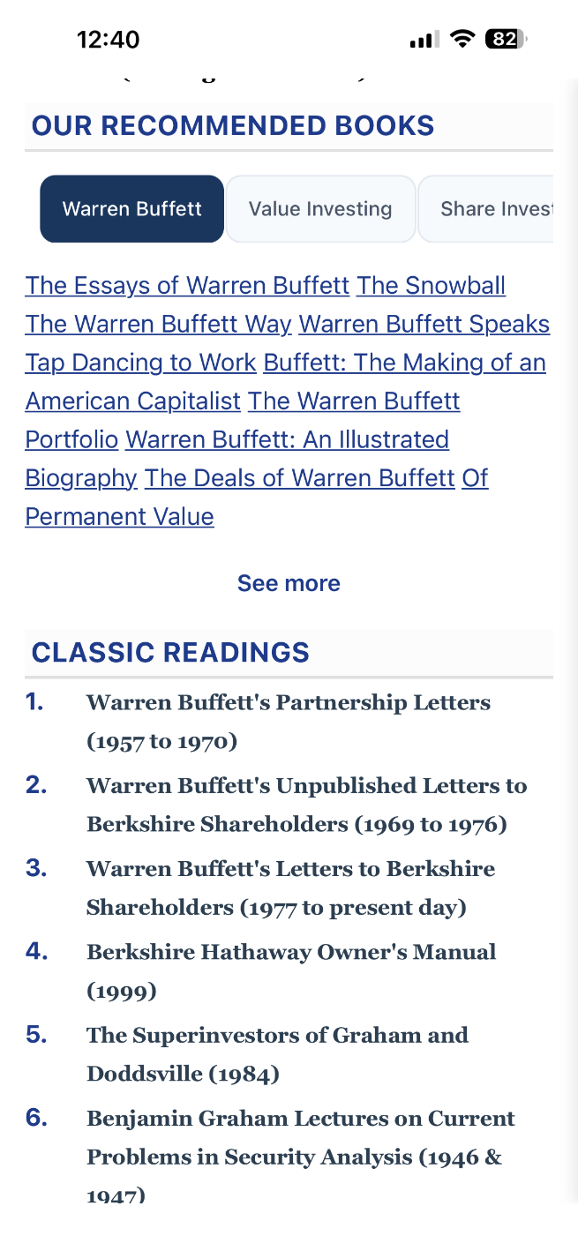
From the Home Page, I’d like the books to link to a book summary page first (instead of going straight to Amazon). I will send you the book summaries via email.
Please make these book titles the same font type and size as the news articles (see further at next page). Also there needs to be a comma dividing each book. Font colour should be black.

Xxx

For the “Wealth Creation” tab, can you please display the following books in the Home Page (in this order):

How to Get Rich, Rich Dad Poor Dad, The Simple Path to Wealth, I Will Teach You to be Rich, The Richest Man in Babylon, The Millionaire Next Door, The Millionaire Mind, The Millionaire Fastlane, The Strategic Millionaire, Millionaire Mission, The Science of Getting Rich, Secrets of the Millionaire Mind, Simple Money Rich Life, $1M Money Models, Money Magnet, Cashflow Quadrant, Get Good With Money, Psychology of Money

For the “Financial Analysis” tab, can you please display the following books in the Home Page (in this order):

Financial Statements, How to Read a Financial Report, Financial Shenanigans, Bemused Investor’s Guide to Company Accounts, Warren Buffett Accounting, Accounting for Beginners, Financial Intelligence, Balance Sheet Basics, Financial Statement Analysis for Value Investors, The Interpretation of Financial Statements, How to Value Company Stocks, Valuation, Damodaran on Valuation, Buffettology

For the “Sales and Marketing” tab, can you please display the following books in the Home Page (in this order):

$100M Offers, $100M Leads, Sell or Be Sold, This Is Marketing, The 1-Page Marketing Plan, 80/20 Sales and Marketing, Gap Selling, The Challenger Sale, The Psychology of Selling, Selling 101, Fanatical Prospecting, Secrets of Closing the Sale, Ninja Selling, Go Pro, Building a Story Brand, The 22 Immutable Laws of Marketing, Exactly What To Say, Sell Like Crazy, How to be Great Salesperson, Way Of the Wolf, New Sales Simplified

OUR RECOMMENDED BOOKS

For the “Warren Buffett” tab, can you please display the following books in the Home Page (in this order). Do not put them in italics on the website:

The Essays of Warren Buffett, The Snowball, The Warren Buffett Way, Warren Buffett Speaks, Tap Dancing to Work, Buffett: The Making of an American Capitalist, The Warren Buffett Portfolio, Warren Buffett: An Illustrated Biography, The Deals of Warren Buffett, Of Permanent Value, The Essential Buffett, The Real Warren Buffett, Berkshire Hathaway Letters to Shareholders, Damn Right!, Poor Charlie’s Almanack

For the “Value Investing” tab, can you please display the following books in the Home Page (in this order).

The Intelligent Investor, Security Analysis (1940), Security Analysis (2008), Benjamin Graham On Value Investing, Value Investing: From Graham to Buffett and Beyond, The Rediscovered Benjamin Graham, The Little Book of Value Investing, The Little Book That Beats the Market, You Can Be A Stock Market Genius, Modern Value Investing, Dhandho Investor, Margin of Safety, Value Investing: Tools and Techniques, Deep Value, F Wall St

For the “Share Investing” tab, can you please display the following books in the Home Page (in this order). You should have 10 lines:

How to Make Money in Stocks, One Up on Wall Street, A Beginner’s Guide to the Stock Market, Common Sense on Mutual Funds, The Little Book of Common Sense Investing, Stocks for the Long Run, The Five Rules for Successful Stock Investing, The Little Book That Builds Wealth, Best Loser Wins, Stock Market Investing, The Bogleheads Guide to Investing, Learn to Earn, The Art of Quality Investing, A Random Walk Down Wall Street

For the “Self-Improvement” tab, can you please display the following books in the Home Page (in this order):

Atomic Habits, The Mountain Is You, Good Vibes Good Life, The Power of Discipline, The Let Them Theory, Stop Overthinking, Breaking the Habits of Being Yourself, The 7 Habits of Highly Effective People, The 15 Invaluable Laws of Growth, Success, No Excuses!, The Master Key System, How to Talk to Anyone, When Things Fall Apart, Self Doubt Workbook for Women, Love Yourself Like Your Life Depends On It, Awaken The Giant Within

For the “Business & Management” tab, can you please display the following books in the Home Page (in this order):

Never Split the Difference, The Lean Startup, Leaders Eat Last, The Coaching Habit, The E-Myth Revisited, Traction, Surrounded By Idiots, Profit First, Personal MBA, The Infinite Game, Your Next Five Moves, Legacy, The Making of a Manager, The New One Minute Manager, The Diary of a CEO, Million Dollar Weekend, Build to Sell, Buy Back Your Time, Business Made Simple, 12 Months to $1 Million, What’s Your Dream, Business Book

For the “Miscellaneous” tab, can you please display the following books in the Home Page (in this order):

The Big Short, Deep Simplicity, Moneyball, Flash Boys, Liar’s Poker, The Fifth Risk, Bull!, Going Infinite, Tools and Weapons, The Third Chimpanzee, Selfish Gene, Three Scientists and their Gods, Investing Between the Lines, The Autobiography of Benjamin Franklin, Extraordinary Popular Delusions and the Madness of Crowds, A Short History of Nearly Everything, The Black Swan, Fooled by Randomness, Smartest Guys in the Room

Xxx

The book image on the left looks stretched. Can we re-format each display to look like the one on the right. I will email the book summaries.
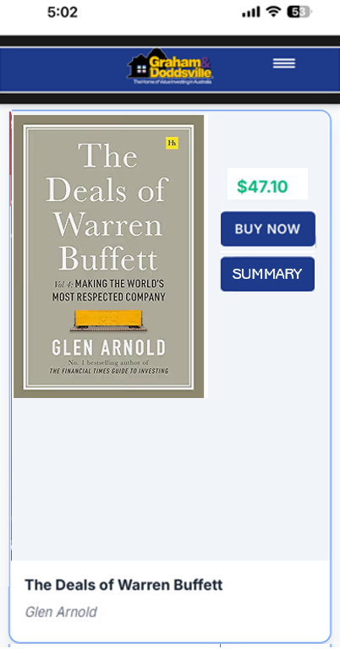
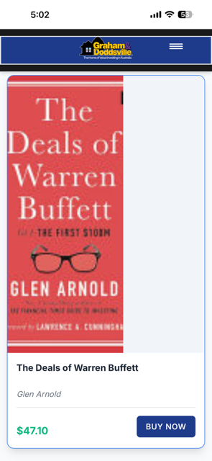
In this third volume of The Deals of Warren Buffett, we trace Warren Buffett's journey as he made Berkshire Hathaway the largest company in America. This enthralling instalment follows …
From “BUY NOW”, the books should link straight to the Amazon book via my Affiliate link.

My Amazon Associate ID is carl0c72-20

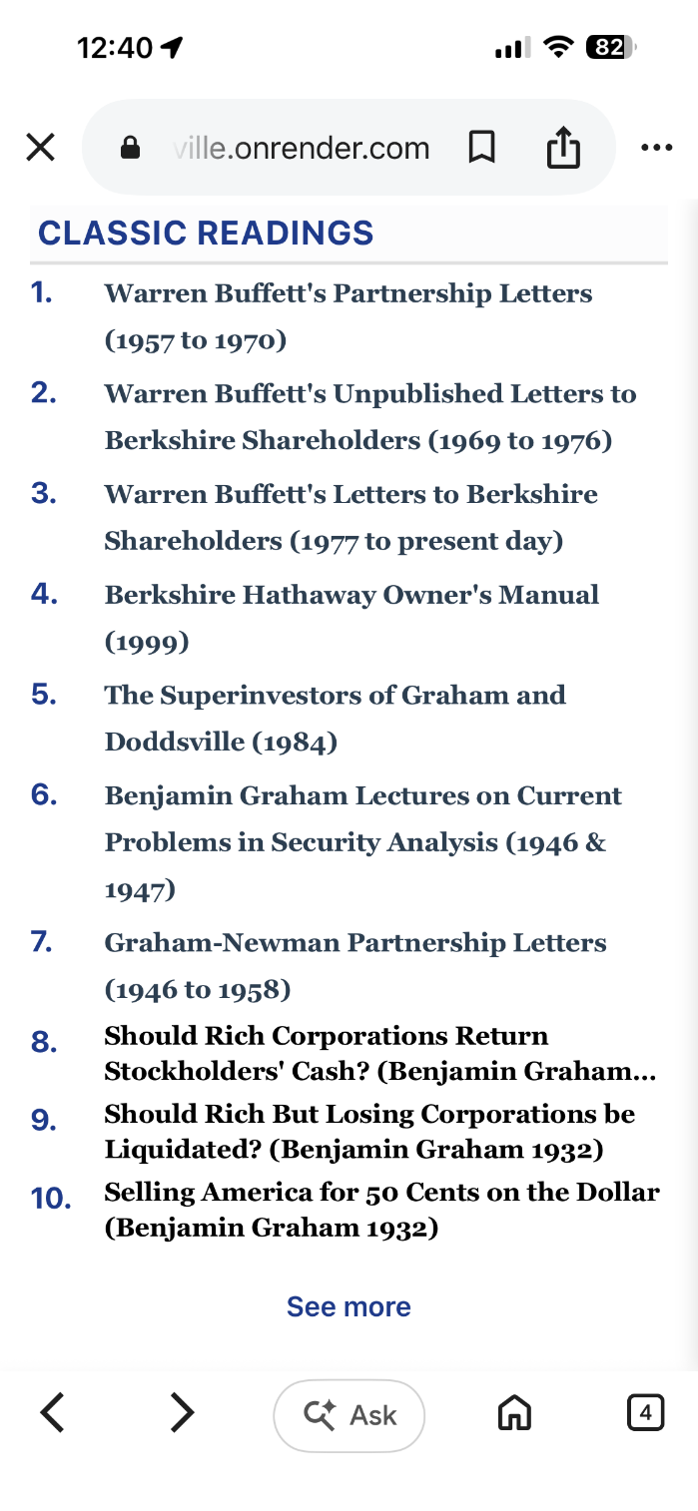
The line spacing of 8-10 needs to be the same as 1-7.

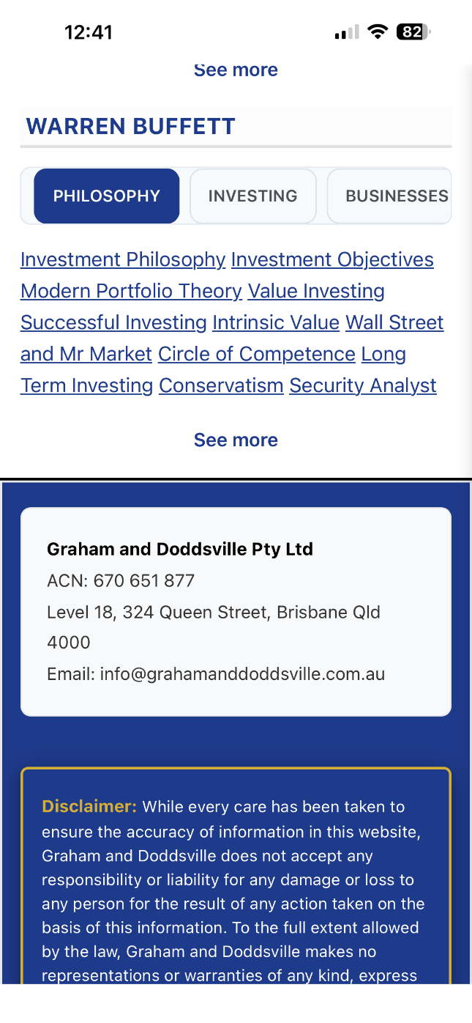
Please make these the same font type and size as the news articles. Also there needs to be a comma dividing each term.

Ddd
For the “Governance” tab, can you please display the following terms in the Home Page (in this order). Do not include the italics:

Annual meetings, Audit Committee, Auditors,
Berkshire Compensation, CEO Compensation, CEO Mistakes, Corporate Charity, Corporate Culture, Corporate Expense, Corporate Governance, Corporate Responsibility, Corporate Strategy, Director Remuneration, Directors' Role, Directors' Weaknesses , Dividend Policy, Executive Compensation, Hiring and Firing, Independent Directors, Organisational Structure, Remuneration Committee, Shareholders, Succession

For the “Accounting” tab, can you please display the following terms in the Home Page (in this order). Do not include the italics:

Accounting Creativity, Accounting Ratios, Accounting Goodwill, Amortization, Book Value, Capital Base, Capital Gain, Cash Flow, Compounding, Debt, Depreciation, Earnings, Earnings Per Share, EBITDA, Economic, Goodwill, Fraud, Full and Fair Reporting, Intangibles, GAAP, Leverage, Liquidation, Look through earnings, Owner Earnings, PE Ratio, Pro Forma Reporting, Realised Gains and Losses, Retention of Earning, Return on Capital, Return on Equity, Valuation

For the “Economics” tab, can you please display the following terms in the Home Page (in this order). Do not include the italics:

Budget Deficit, Currency, Globalisation, Global Economy, Gross Domestic Product, Inflation, Interest Rates, International Trade, Macroeconomics, Recession, Trade Imbalance, US Economy

For the “Miscellaneous” tab, can you please display the following terms in the Home Page (in this order). Do not include the italics:

Benjamin Graham, Character, Charlie Munger, David Dodd, Happiness, Love, Partnership, Philanthropy, Public Pension, Success, Taxation, Unconventional Commitments
For the “Philosophy” tab, can you please display the following terms in the Home Page (in this order). Do not include the italics:

Investment Philosophy, Investment Objectives,
Modern Portfolio Theory, Value Investing, Successful Investing, Intrinsic Value, Wall Street and Mr Market, Circle of Competence, Long Term Investing, Conservatism, Security Analyst, Margin of Safety, Market Forecasting, Market Timing, Speculation, Performance Standards, Performance Measurement, Mistakes, Frictional Costs, Capital Allocation, Market Bubble, Market Downturn, Exit Strategy, Berkshire Disclosure, Value Investors

For the “Investing” tab, can you please display the following terms in the Home Page (in this order). Do not include the italics:

Stock Market, Portfolio Allocation, Buying Criteria, Selling Criteria, Investment Strategy,
Investment Advice, Investment Risk, Volatility
Rumours, Technical Analysis, Share Buybacks,
Share Issues, Stock Splits, Stock Options, Book Recommendations, Indexing, Arbitrage, Cigar Butt Investing, Mergers and Acquisitions, Workouts, Derivatives, The Dow, Fees, Bonds, Gold, Diversification, Initial Public Offering, Convertible Preferred Stock, Junk Bonds, Private Equity, Real Estate

For the “Businesses” tab, can you please display the following terms in the Home Page (in this order). Do not include the italics:

Good Businesses, Economic Moat, Good Managers, Poor Businesses, Poor Managers, Airlines, Auto Insurance, Banks, Berkshire Hathaway, Controlled Businesses, Derivatives Business, Float, Franchises, Insurance, Investment Banks, Investment Companies, Investment Managers, Manufactured Housing, Paper, Property Casualty Insurance, Reinsurance, Retail, Retroactive Insurance, Shoes, Super Cat Insurance, Technology, Television, Textile, Transport, Utilities

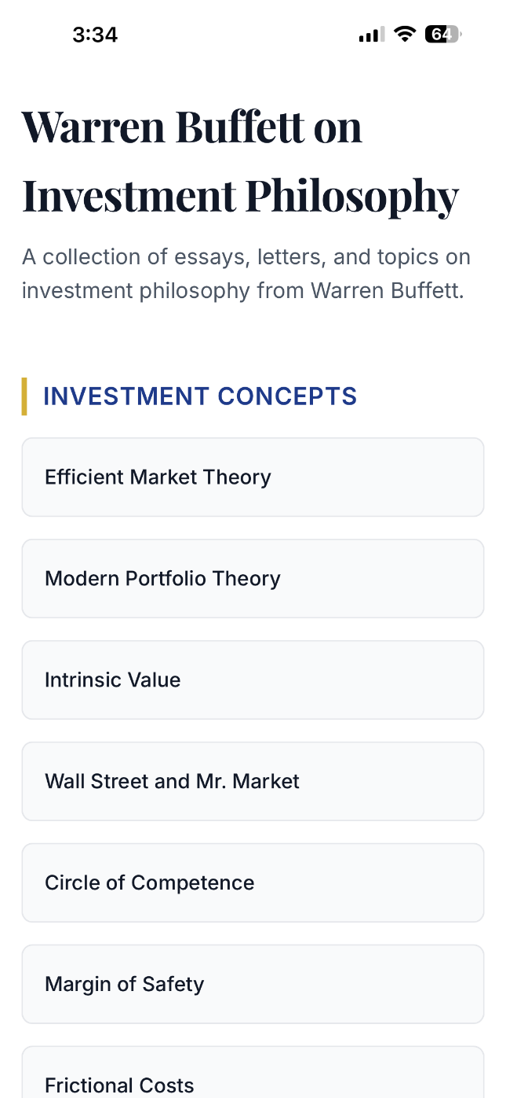
The heads and subheadings used should be the same as in the current G&D website (check out www.grahamanddoddsville.com.au).

Also the terms listed under each subheading should be the same as in the current G&D website.

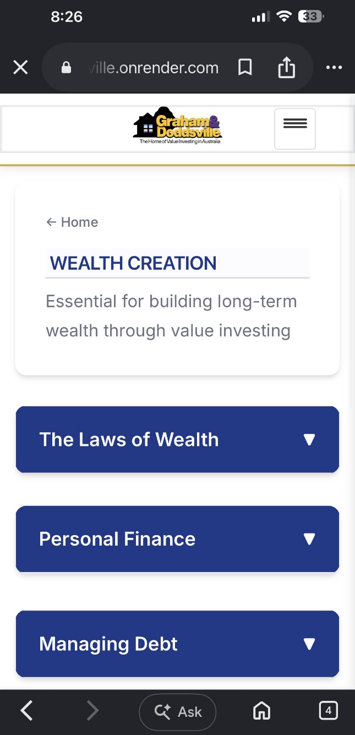
Please change the descriptions of the tabs to the following:

Wealth Creation
The beginner’s guide to money, saving, managing debt and investing wisely

Legal & Taxation
Legal structures, asset protection, taxation, estates, duties & insurance

Financial Markets
Understand how global financial markets work and the forces that drive them

Share Investing
Learn how shares work, how to think like an investor and build strong portfolios

Greatest Investors
Discover the legendary figures who shaped the world of value investing

Investment Analysis
Understand industries, business quality, corporate actions and accounting tricks

Financial Statement Analysis
How to read and analyse balance sheets, P&Ls and cash flow statements

Stock Valuation
How to value stocks based on revenue, earnings, dividends, assets and cash flow

Economics
Insights into the global and domestic economy, policies, inflation and indicators

Professional Advisers
The ultimate guides to the experts who can help you navigate the world of investing

Financial Products
The most comprehensive guides to every asset you can possibly invest in

Resources
Handy tools, screeners, forums, glossaries, and links to boost your learning

Events & Seminars
Discover courses, webinars, podcasts and training to grow your investing skills

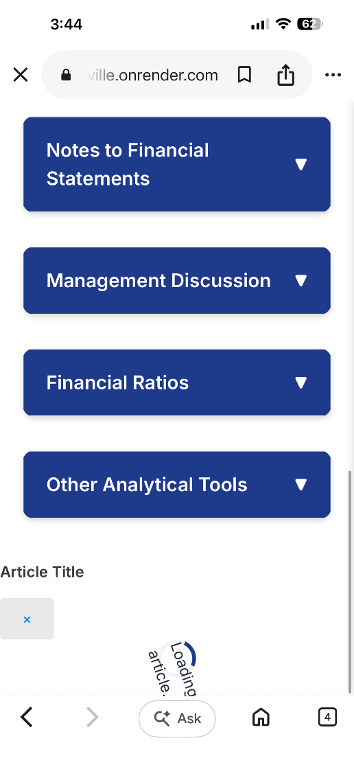
This appears at the bottom of the “Financial Statement Analysis” page.
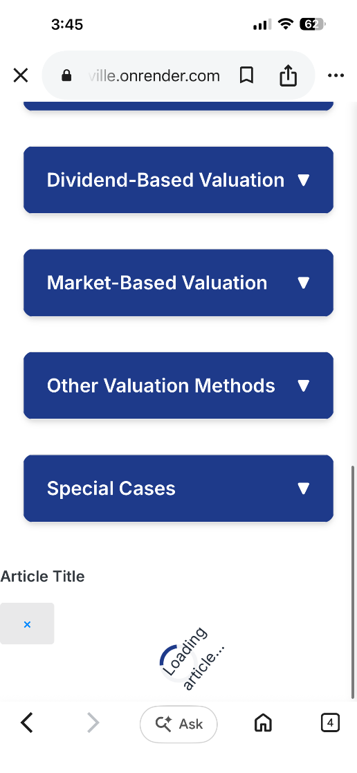
This appears at the bottom of the “Financial Statement Analysis” page.

